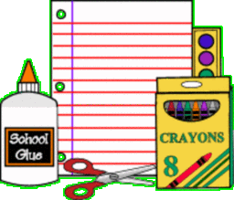
Borland Elementary
Suggested School Supply List

3rd Grade | 4th Grade | 5th Grade
- 5 – two pocket folders with fasteners  - Dry Erase Markers  - 1 eraser to use on whiteboards (an old clean sock would be fine ☺)  - Crayons, Colored Pencils and Markers  - One inch, three ring binder with pockets  - 2 pens (any dark color but black)  - Glue Sticks  - 2 Dozen #2 Pencils  - Pencil Box  - Ear buds/headphones  - Erasers  - Gym shoes  - Refillable water bottle | - Ear buds/headphones (may need a backup pair or two)  - 2 dozen, #2 pencils  - Erasers  - Pencil box/pouch  - Crayons, Colored Pencils and Markers  - Highlighter  - Glue Sticks  - Colored Pens (not black)  - Dry Erase Markers  - 1-2 composition books or spiral bound notebooks  - 1 two pocket folders with fasteners  - Scissors  - Gym shoes  - Refillable water bottle | - Pencil pouch that zips  - Crayons, Colored Pencils, and Markers  - #2 Pencils  - Dry Erase Markers  - Glue Sticks  - Scissors  - Erasers  - Highlighter (any color)  - One inch, three ring binder with pockets  - Gym Shoes  - Ear buds/headphones

In addition, classrooms would appreciate:
Kleenex and Clorox Wipes
Backpacks with wheels are NOT allowed at Borland because they do not fit in the lockers

